SOFTWARE REQUIREMENT SPECIFICATION

STUDENT INFORMATION SYSTEM

INTRODUCTION:

The Student information system can handle all the details about a student. The details include college details, department details, and student details, staff Details, Exam details. The Student Information system is an automated version of manual Student Information System.

PURPOSE:

Student information System deals with all kind of student details, academic related reports, college details, course details, curriculum, and batch details. It tracks all the details of a student from the day one to the end of his course which can be used for all reporting purpose, tracking of attendance, completed semesters years coming semester year curriculum details, exam details, final exam results and all these will be available for future references too.

SCOPE:

Student Information System is developing for general purpose and used to replace old paper work system and PUMS. OSIMS is to build upon the existing information system PUMS in order to efficiently provide student information to teachers and school administration .This increase in efficiency of result making, provide result to parents, give feedback to student, finally, publication and email student result. It provides a mechanism to edit the student information from which makes the system flexible.

ABBREVATIONS:

OSIMS -- Online Student Information Management System.

PUMS -- Project Units Management System.

OVERALL DESCRIPTION:

The Student Information system allows authorized members to access the records of the Academically Registered Students. It can be used in various Educational institutes across the globe and simplifies working of institutes.

FUNCTIONAL COMPONENTS OF THE PROJECT:

There are registered people in the system. Some are faculty and the other is students.

Following is the list of functionalities of the system:

* The system can record the details of the students so that the student can check them online.
* It can also record the marks of the student.
* Stores the details of the department and courses taken previously.
* Stores the attendance details.
* Can view the details of the staff attending their classes.

STUDY OF THE SYSTEM:

In the flexibility of the uses the interface has been developed a graphics concept in mind, associated through a browser interface. The GUI’S at the top level have been categorized as

1. Administrative user interface.
2. The operational or generic user interface.

The administrative user interface concentrates on the consistent information that is practically, part of the organizational activities and which needs proper authentication for the data collection. The interfaces help the administrations with all the transactional states like Data insertion, Data Deletion and Date Updating along with the extensive date search capabilities.

The operational or generic user interface helps the user upon the system in transactions through the existing data and required services. The operational user interface also helps the ordinary users in managing their own information helps the ordinary users in managing their own information in customized manner as per the assisted flexibilities.

NO OF MODULES:

The modules involved in the system are

1. College and Department details
2. Student Details
3. Staff Details
4. Exam Details

Module I: College and Department Details

* This module deals with the college details and different departments in the college.
* Department details contain course, curriculum and batch details.

Module II: Student Details

* This module deals with the student academic details and personnel details.

Module III: Staff Details

* In the Staff Module that maintains about the staff Information about the classes timetable, attendance etc.

Module IV: Exam Details

* This module deals with the student exam details.

INPUTS AND OUTPUTS:

The main inputs, and outputs and major components of the system are as follows:

INPUTS:

* Admin enters his or her user id and password.
* Student enters his or her user id and password.
* Student can check the percentage of the attendance.
* Admin can edit the details of the staff and the student and so on.
* Staff can upload the attendance, marks of the student.

OUTPUTS:

* Admin gets his homepage.
* Student gets his homepage.
* Staff/faculty gets his homepage.
* Display the attendance status, marks, and personal details.
* Admin get staff/faculty, student details.

PERFORMANCE REQUIREMENTS:

Performance is measured in terms of the output provided by the application. Requirement specification plays an important part in the analysis of a system. Only when the requirement specifications are properly given, it is possible to design a system, which will fit into required environment. It rests largely in the part of the users of the existing system to give the requirement specifications because they are the people who finally use the system. This is because the requirements have to be known during the initial stages so that the system can be designed according to those requirements. It is very difficult to change the system once it has been designed and on the other hand designing a system, which does not cater to the requirements of the user, is of no use.

The requirement specification for any system can be broadly stated as given below:

* The system should be able to interface with the existing system
* The system should be accurate
* The system should be better than the existing system
* The existing system is completely dependent on the user to perform all the duties.

FEASIBILITY REPORT:

Preliminary investigation examine project feasibility, the likelihood the system will

Be useful to the organization. The main objective of the feasibility study is to test the Technical, Operational and Economical feasibility for adding new modules and debugging old running system. All system is feasible if they are unlimited resources and infinite time.

There are aspects in the feasibility study portion of the preliminary investigation:

* Technical Feasibility
* Operation Feasibility
* Economical Feasibility

Technical Feasibility

The technical issue usually rose during the feasibility stage of the investigation

Includes the following:

* Does the necessary technology exist to do what is suggested?
* Do the proposed equipments have the technical capacity to hold the data required to use the new system?
* Will the proposed system provide adequate response to inquiries, regardless of the number or location of users?
* Can the system be upgraded if developed?
* Are there technical guarantees of accuracy, reliability, ease of access and data security?

Earlier no system existed to cater to the needs of ‘Secure Infrastructure Implementation System’. The current system developed is technically feasible. It is a web based user interface. Thus it provides an easy access to the users. The database’s purpose is to create, establish and maintain a workflow among various entities in order to facilitate all concerned users in their various capacities or roles. Permission to the users would be granted based on the roles specified. Therefore, it provides the technical guarantee of accuracy, reliability and security. The software and hard requirements for the development of this project are not many and are available as free as open source. The work for the project is done with the current equipment and existing software technology. Necessary bandwidth exists for providing a fast feedback to the users irrespective of the number of users using the system.

Operational Feasibility

Proposed projects are beneficial only if they can be turned out into information system. That will meet the organization’s operating requirements. Operational feasibility aspects of the project are to be taken as an important part of the project implementation. Some of the important issues raised are to test the operational feasibility of a project includes the following: -

* Is there sufficient support for the management from the users?
* Will the system be used and work properly if it is being developed and implemented?
* Will there be any resistance from the user that will undermine the possible application benefits?

This system is targeted to be in accordance with the above-mentioned issues.

Beforehand, the management issues and user requirements have been taken into

Consideration. So there is no question of resistance from the users that can undermine the possible application benefits.

The well-planned design would ensure the optimal utilization of the computer resources and would help in the improvement of performance status.

Economic Feasibility

A system can be developed technically and that will be used if installed must still be a good investment for the organization. In the economical feasibility, the development cost in creating the system is evaluated against the ultimate benefit derived from the new systems. Financial benefits must equal or exceed the costs. The system is economically feasible. It does not require any addition hardware or software. Since the interface for this system is developed using the existing resources and technologies available. There is nominal expenditure and economical feasibility for certain.

ER DIAGRAMS

* The relation upon the system is structure through a conceptual ER-Diagram, which not only specifics the existential entities but also the standard relations through which the system exists and the cardinalities that are necessary for the system state to continue.
* The entity Relationship Diagram (ERD) depicts the relationship between the data objects. The ERD is the notation that is used to conduct the date modeling activity the attributes of each data object noted is the ERD can be described resign a data object descriptions.

* The set of primary components that are identified by the ERD are
  + Data object
  + Relationships
  + Attributes
  + Various types of indicators.

The primary purpose of the ERD is to represent data objects and their relationships. 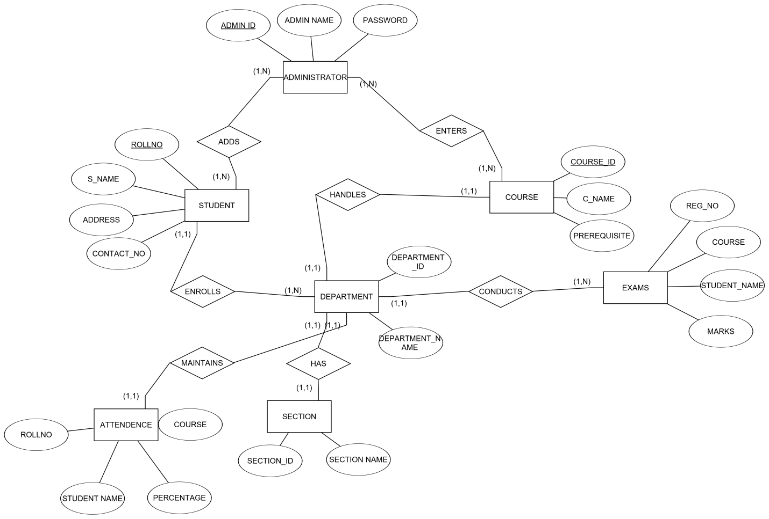

DATAFLOW DIAGRAMS:

Zeroth level DFD diagram:

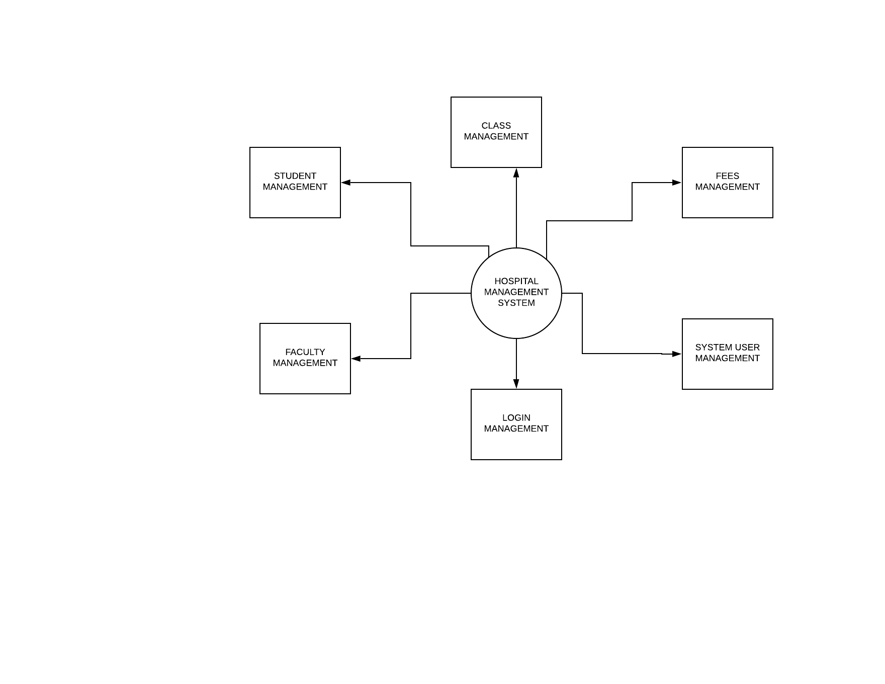

First level DFD diagram:

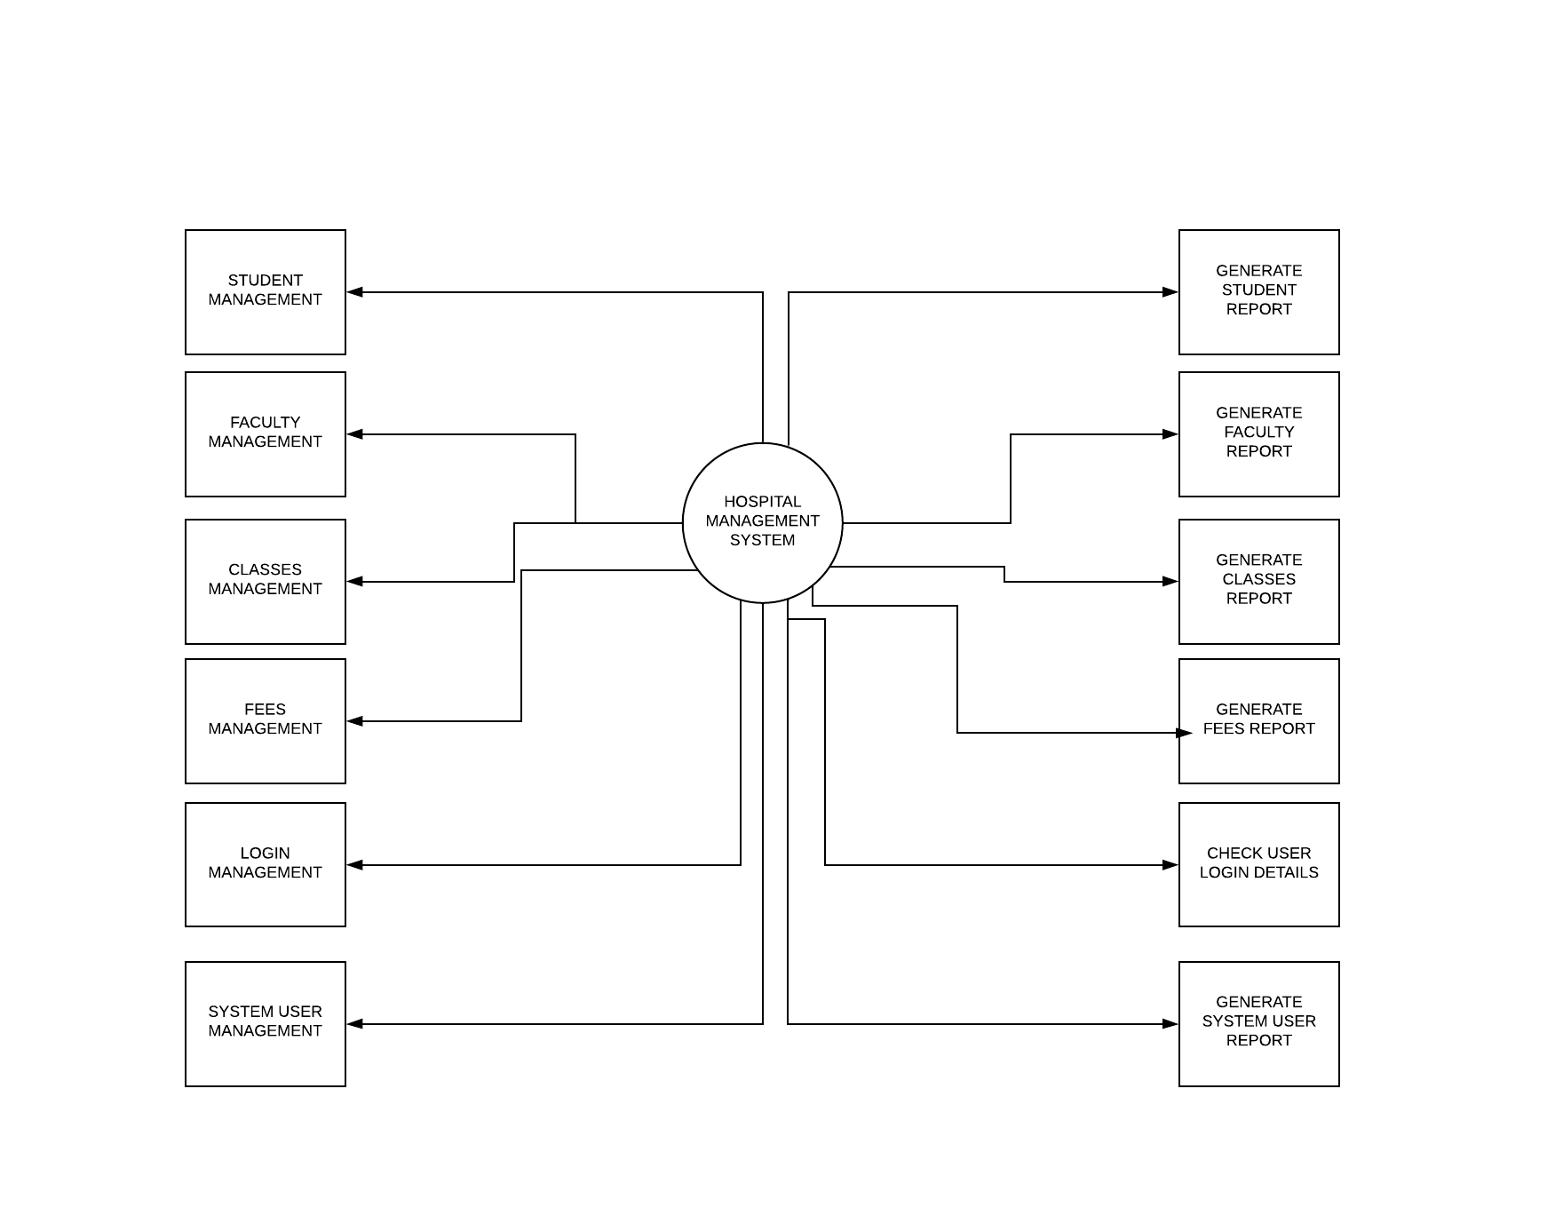

Second level DFD diagram:

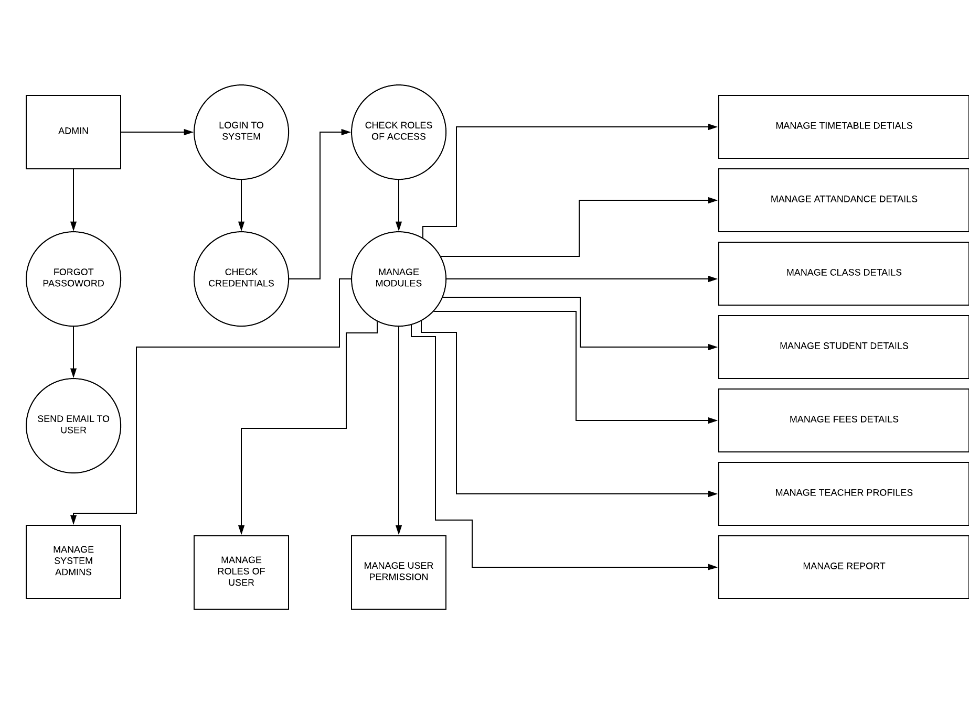

Third level DFD diagram:

